* Props: general convention. 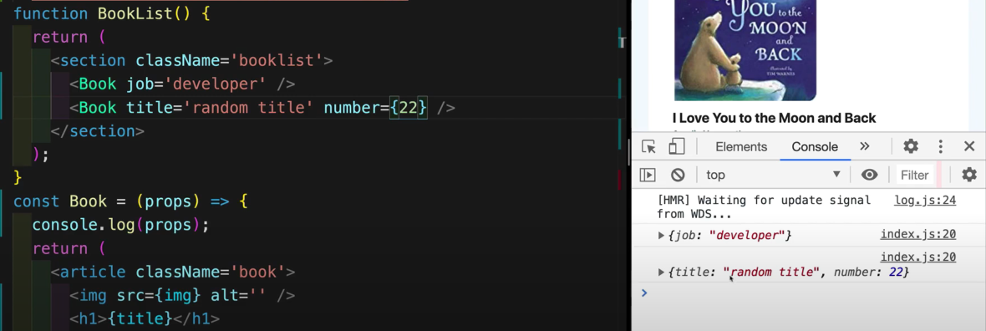 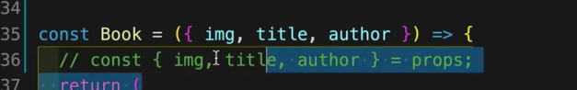
* Event Handler: 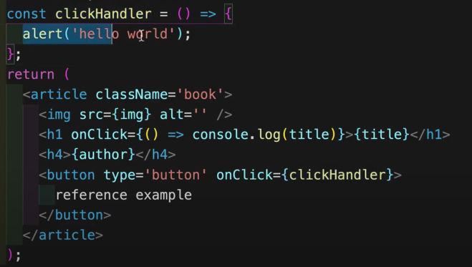
* UseState:
  + array:
    - Text

      Description automatically generated
    - A picture containing text, black, screen

      Description automatically generated
  + **To remove from array:** **Text

    Description automatically generated**
* Multiple Returns: 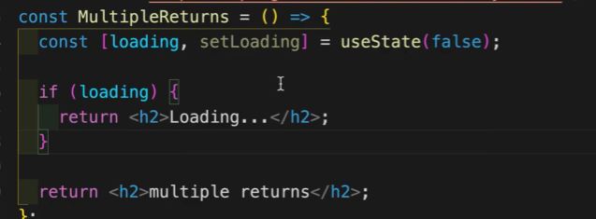
* 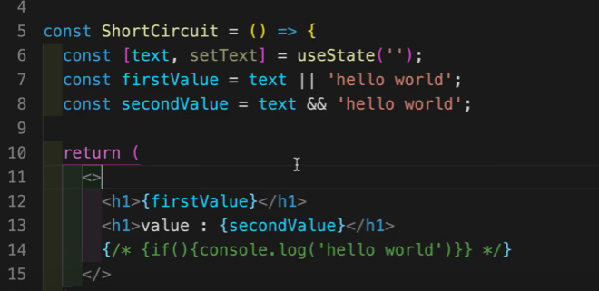
* Ternary operator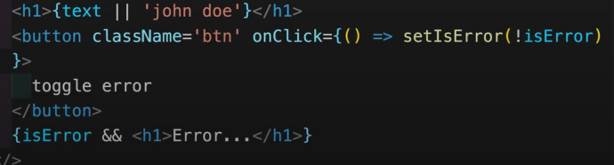
* Toggle: 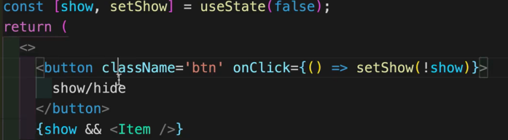
* Handling Inputs: 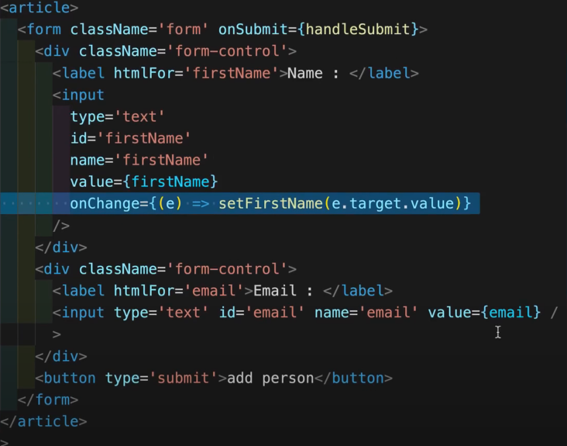
* UseRef: used to handle subit value.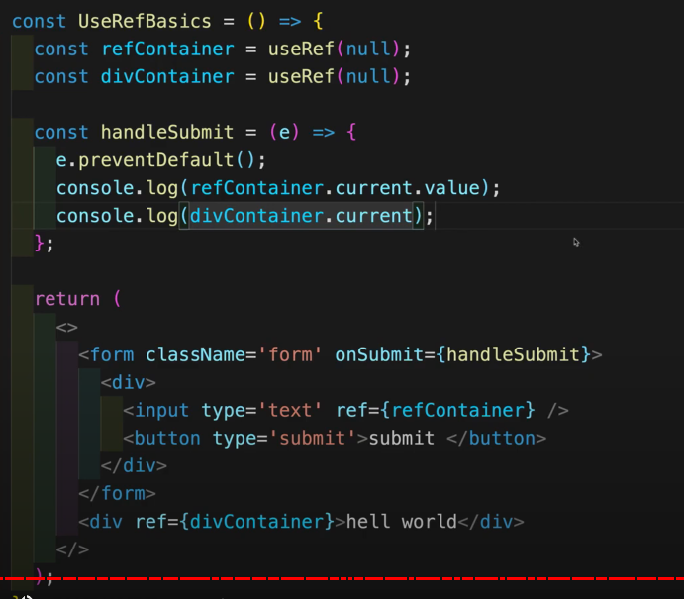
* UseContext: 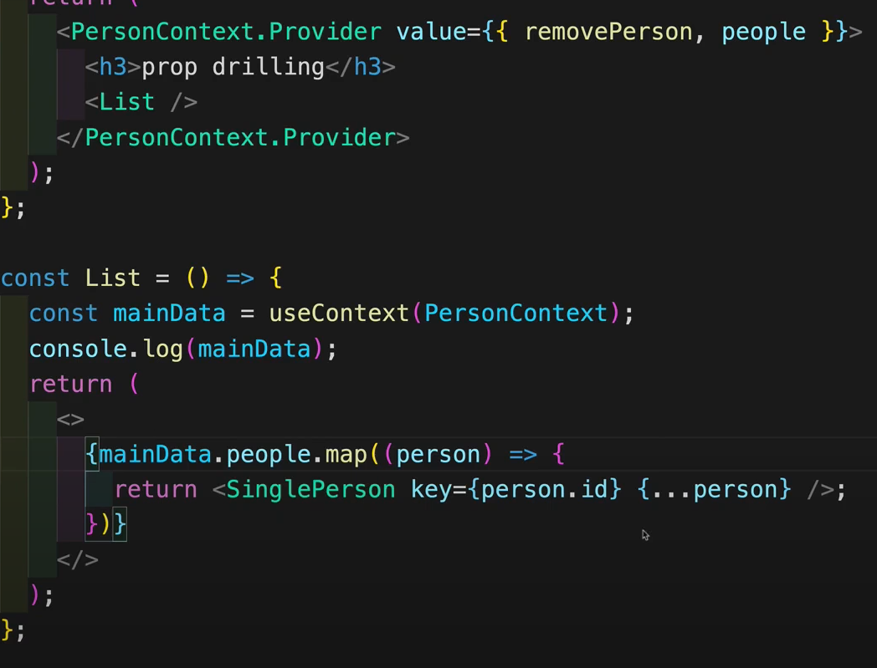
* React Router: 